AIM:-
10 Creating graphical reports using ,ggplot2 (R).
OUTPUT:-
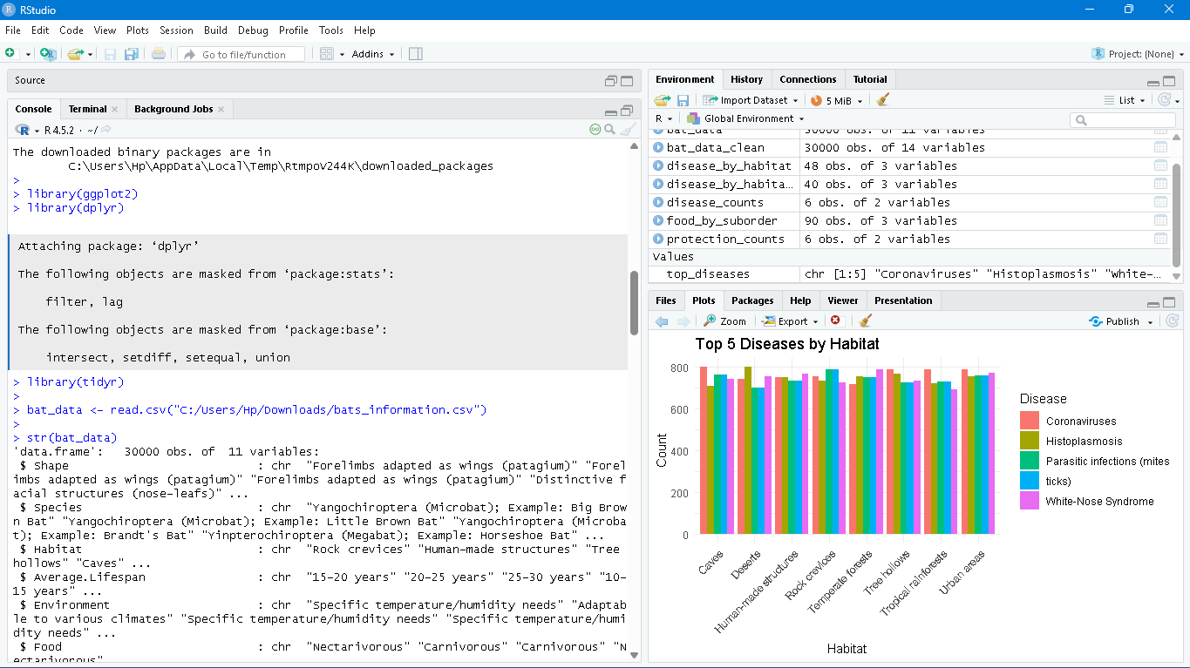
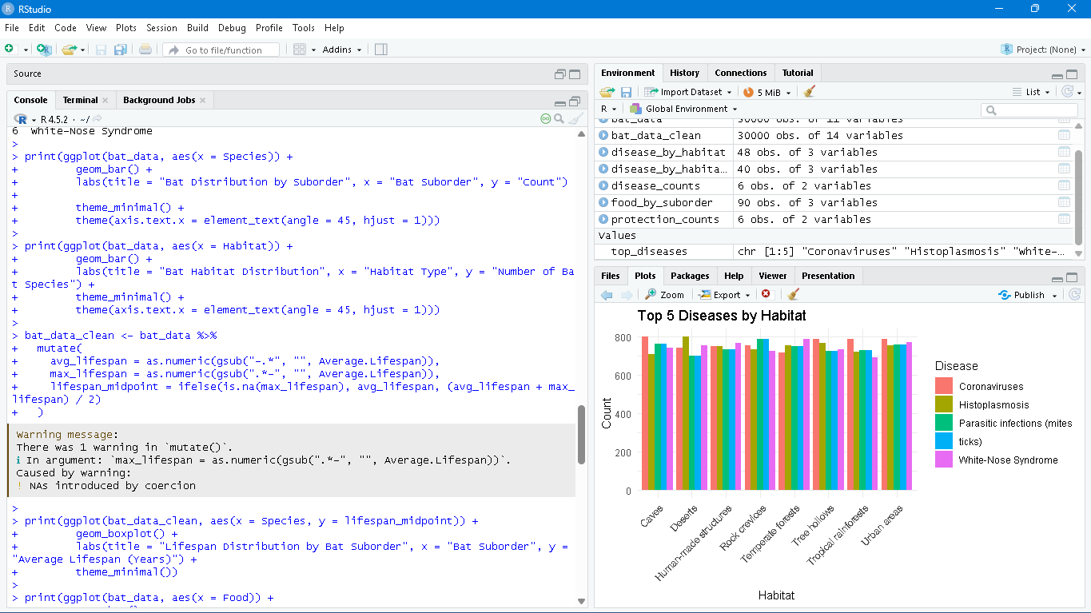
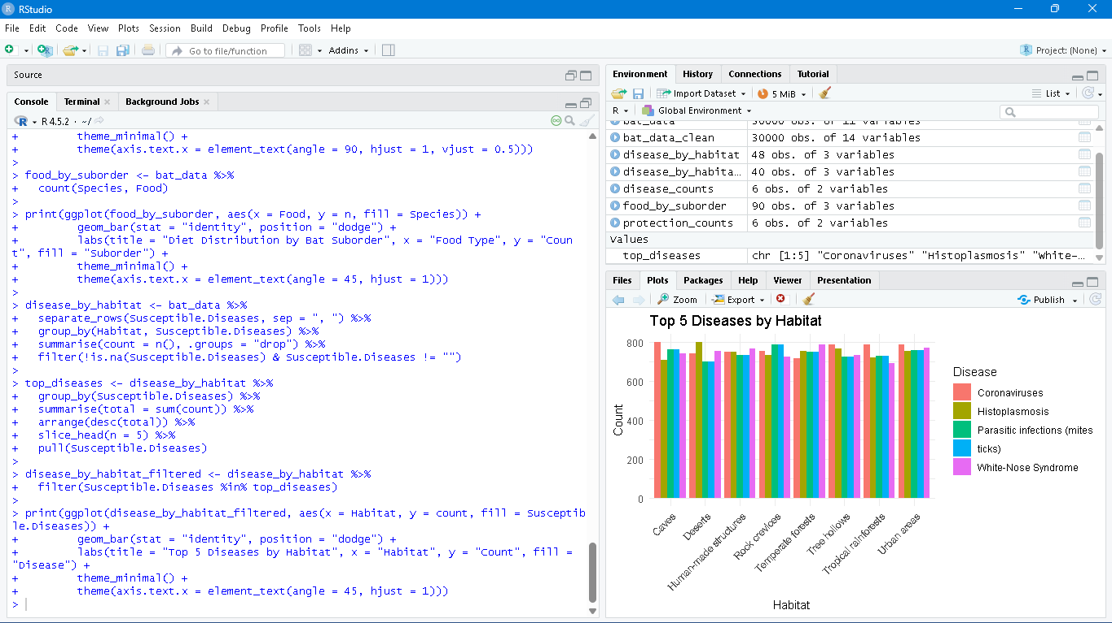

AIM:-
11 Generating histograms and box plots using ggplot2 (R).
OUTPUT:-
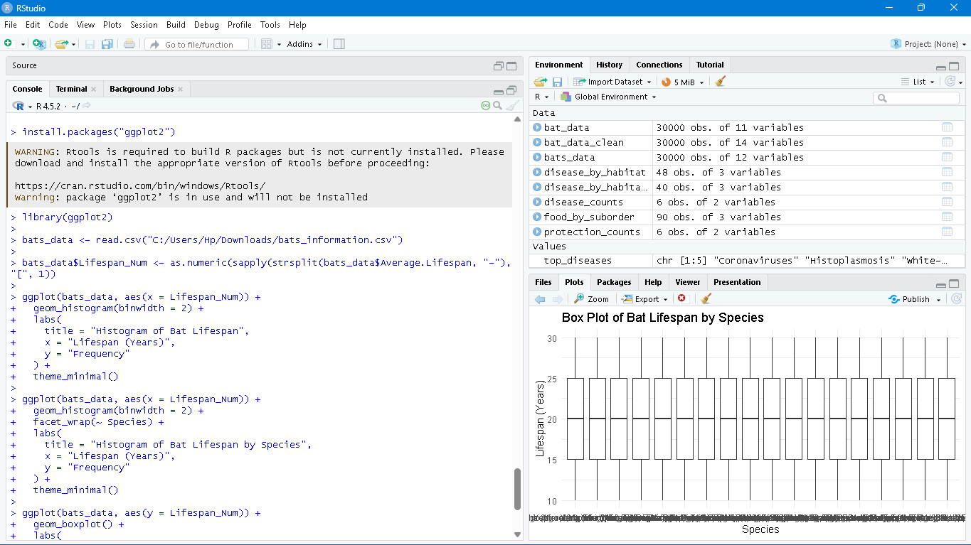
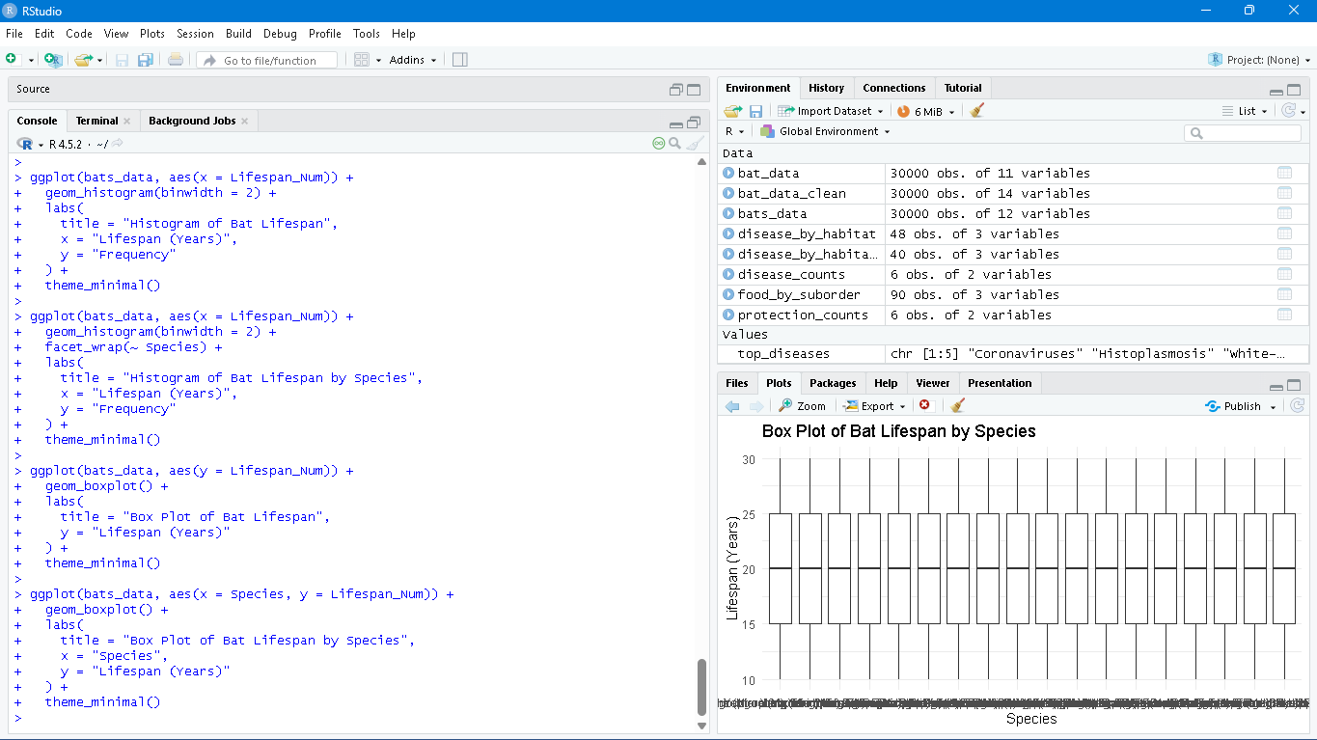
AIM:-
12 Generating correlation matrices using cor() (R).
OUTPUT:-
